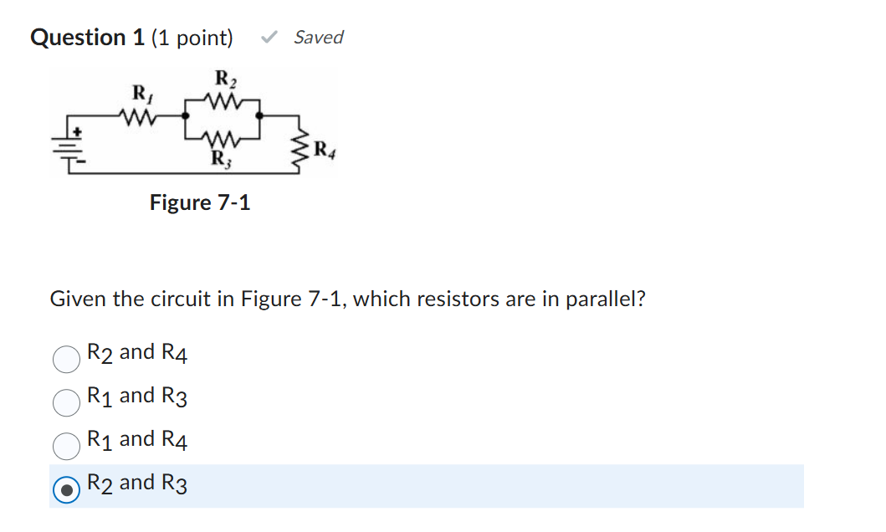

Question 2 (1 point)

Saved
If a 15 kΩ resistor, 0.53 MΩ resistor and 0.63 MΩ resistor are connected in parallel across an 18 V source, what is the total current if the .53 MΩ resistor opens?
Question 2 options:
12.3 mA
1.23 μA
0.123 A
1.23 mA

Question 3 (1 point)

Saved
If fifteen 3.2 MΩ resistors are connected in parallel across 20 V, R_{T} equals ________.
Question 3 options:
2.1 M Ω
213 kΩ
0.0213 MΩ
0.125 MΩ

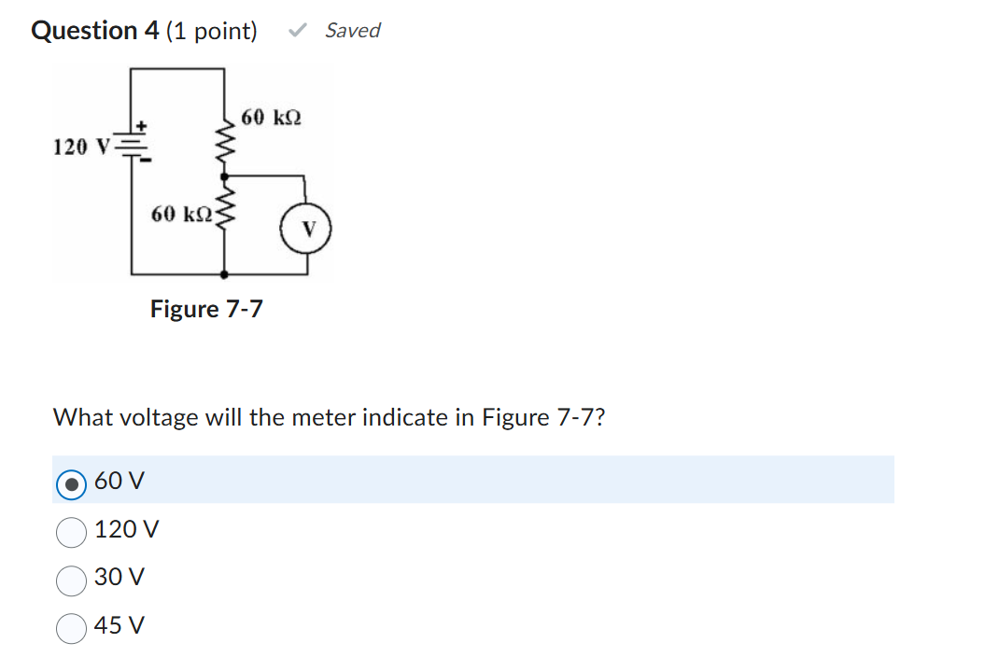

Question 5 (1 point)

Saved
If a 470 Ω resistor, 210 Ω resistor and 75 Ω resistor are connected in parallel, what is the approximate value for R_{T}?
Question 5 options:
22 Ω
47 Ω
755 Ω
50 Ω

